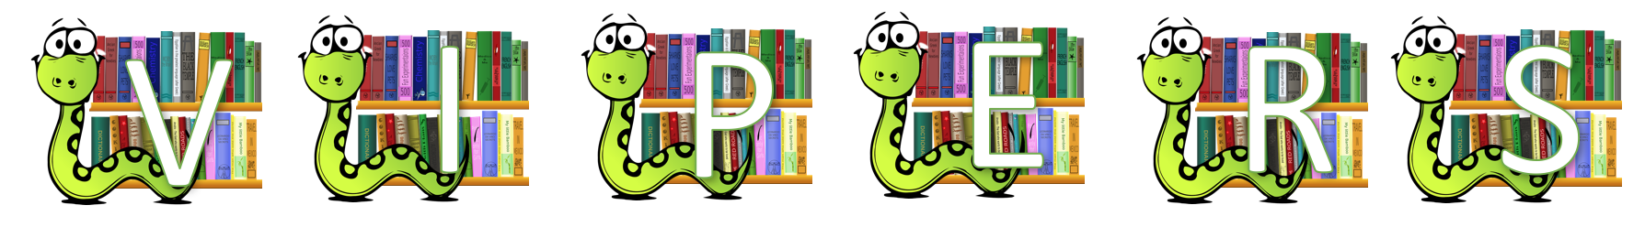

Text title:
 | Questions: | Pupil Answers:
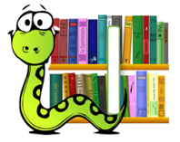

Text title:
 | Questions: | Pupil Answers:

Text title:
 | Questions: | Pupil Answers:

Text title:
 | Questions: | Pupil Answers:

Text title:
 | Questions: | Pupil Answers:

Text title:
 | Questions: | Pupil Answers:

